**OBJECTIVES:**

To design, fabricate and measure a stepped-impedance low-pass filter having maximally flat response and cut-off frequency of 2.5 GHz with an attenuation of more than 20 dB at 4GHz. The line impedance of filter is 50 Ω, highest line impedance is 120 Ω, and the lowest is 20 Ω.

**THEORY:**

A filter is a two-port network used to control the frequency response at a certain point in an RF or microwave system by providing transmission at frequencies within the pass-band of the filter and attenuation in the stop-band of the filter. Typical frequency responses include lowpass, high-pass, band-pass, and band-reject characteristics.

**LUMPED ELEMENTS:** If the size of an element is smaller than the wavelength of applied signals, then it is a lumped elements. The effect of wave propagation can be neglected. There are only minimal phase difference between the input and output signals in lumped elements. The size of lumped elements is less than 1/20 times the operating guided wavelength. Example: Resistors, capacitors and inductors.

**MAXIMALLY FLAT RESPONSE:** The frequency response of the Butterworth filter is maximally flat in the paasband. A Butterworth filter is a type of signal processing filter designed to have a frequency response as flat as possible in the passband. The number of reactive elements used in the filter circuit will decide the order of the filter.

**INSERTION LOSS:** Insertion loss is the amount of energy that a signal loses as it travels along a cable link. It is a natural phenomenon that occurs for any type of transmission—whether it's electricity or data. This reduction of signal, also called attenuation, is directly related to the length of a cable—the longer the cable, the greater the insertion loss. Insertion loss is also caused by any connection points along a cable link (i.e., connectors and splices).

TRANSMISSION COEFFICIENT:The transmission coefficient is used in [physics](https://en.wikipedia.org/wiki/Physics) and [electrical-engineering](https://en.wikipedia.org/wiki/Electrical_engineering) when [wave-propagation](https://en.wikipedia.org/wiki/Wave_propagation) in a medium containing [discontinuities](https://en.wikipedia.org/wiki/Discontinuity_(mathematics)) is considered. A transmission coefficient describes the amplitude, intensity, or total power of a transmitted wave relative to an incident wave.

**Return loss (S11) and Forward Transmission (S21):** S parameter describes the relationship between the terminals and input-output ports of antenna system in terms of power. Return loss of the proposed filter is also called as the S11 parameter. S11 parameter represents the amount of power at input port of LPF which is reflected back and the remaining power which is transmitting in LPF. It is basically the reflected power calculation. S21 represents the power received at port 2 due to the excitation at port 1. For instance if the S21 is 0 dB means that all the power entering at port 1 is delivered to the port 2. If the S21 is -10 dB means that only 10% of the entering power at port 1 is reaching at the port 2. Same analogy can be taken for the reflected power at port 1.

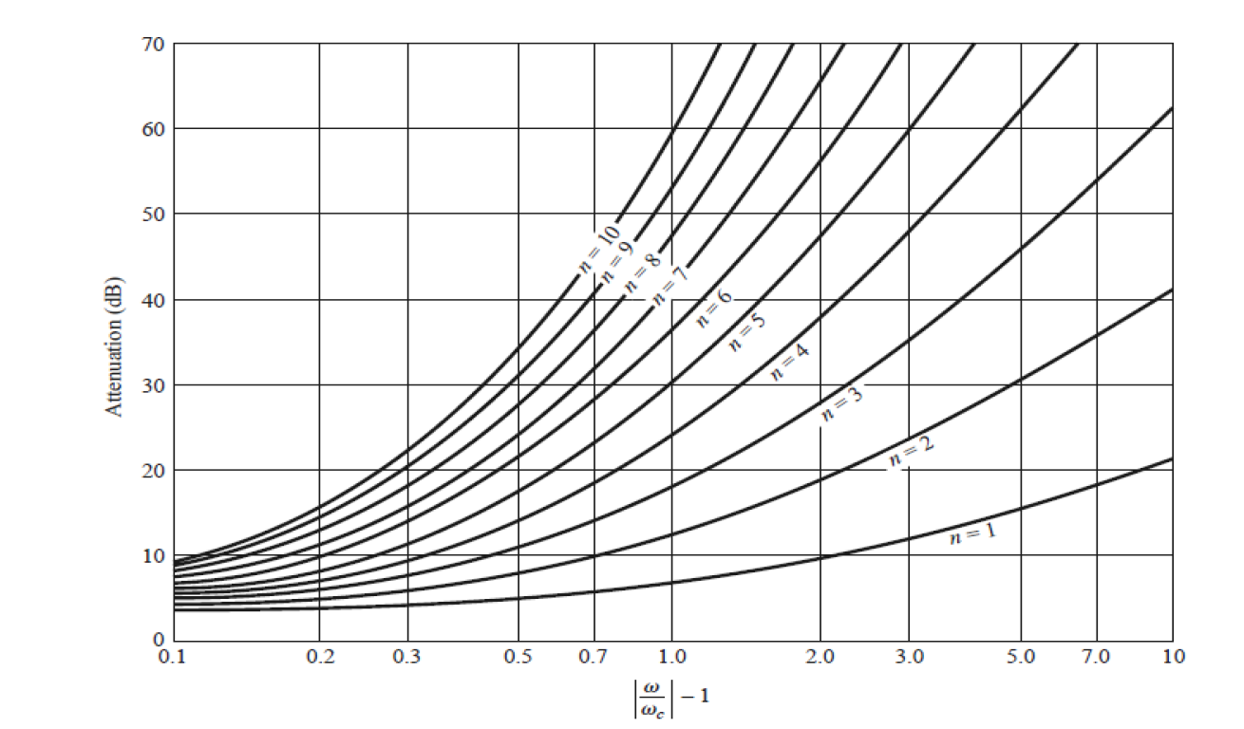

**Construction & Working of Micro strip Antennas**: One of the simplest ways to implement a low pass filter in microstrip is to use alternating sections of very high and very low characteristic impedance lines where the series inductors of a low-pass prototype can be replaced with high-impedance line sections (ZO = Zh), and the shunt capacitors can be replaced with low-impedance line sections (ZO = Zl).

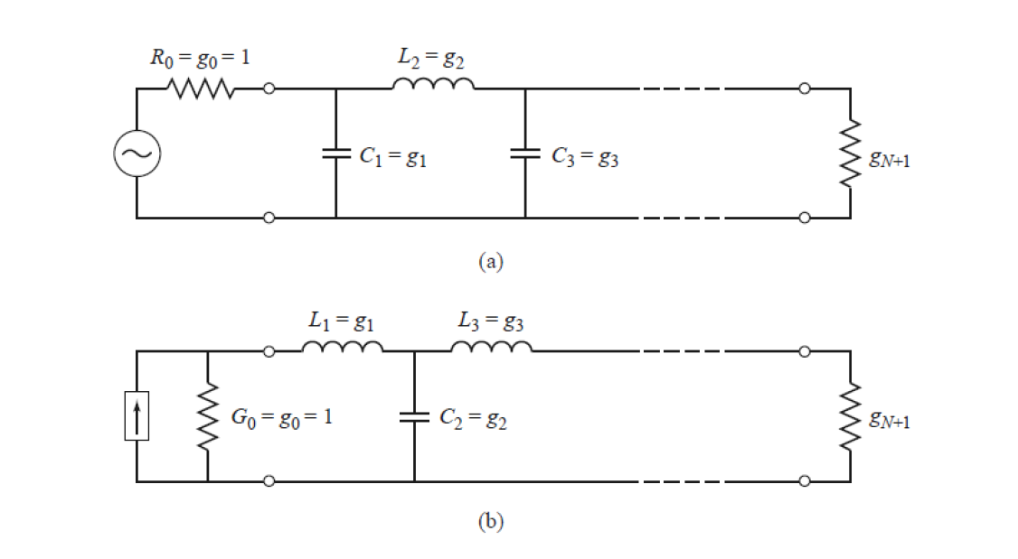

Fig. 1: Ladder circuits for low-pass filter prototypes and their element definitions (a)Prototype beginning with a shunt element (b) Prototype beginning with a series element.

**There are several Parameters which will be used in this designing and fabrication process of Microstrip Lowpass Filter. They are given below:**

1. The electrical lengths of the inductor sections can be calculated as

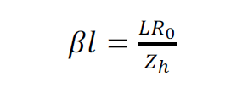

2. The electrical length of the capacitor sections as

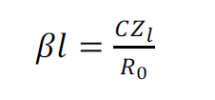

3. For maximally flat network, the gks (with gO =gN+1= 1) can be obtained as

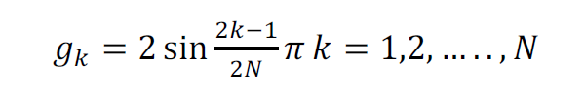

4. Formula for the order of filter

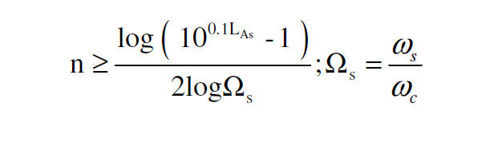

Where, LAs is attenuation, wc  is the cutoff frequency.

Some values which are given in the manual are :

* Cutoff Frequency = 2.5 GHz
* Ɛsub =4.4
* tsub =1.6mm
* h1=1.6mm (substrate thickness)
* ZO =50Ω
* ZL =20Ω
* Zh =120Ω.

**CIRCUIT DIAGRAM:**

Using all the above dimensions, we have designed this circuit of Microstrip Lowpass Filter on HFSS software which is shown below.

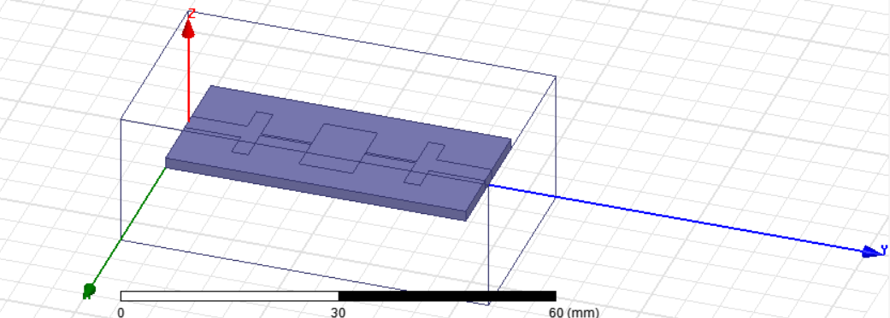

**MATHEMATICAL ANALYSIS:**

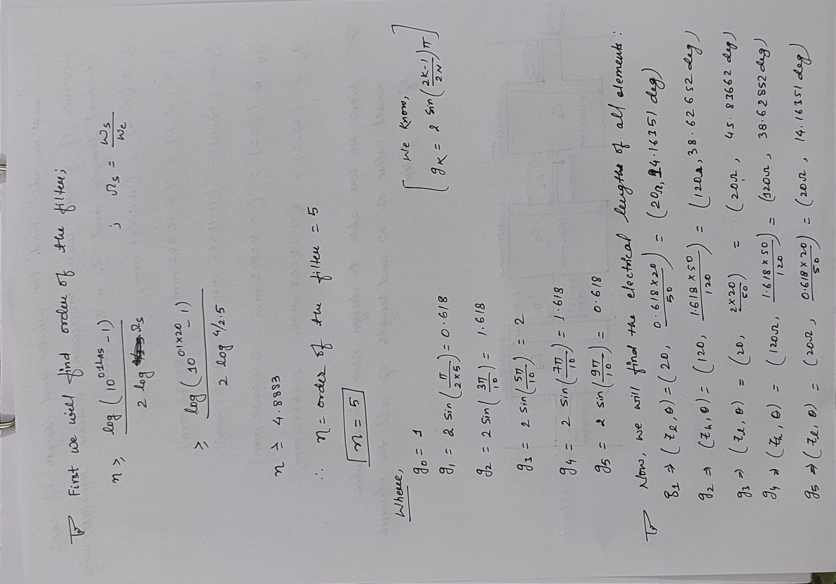

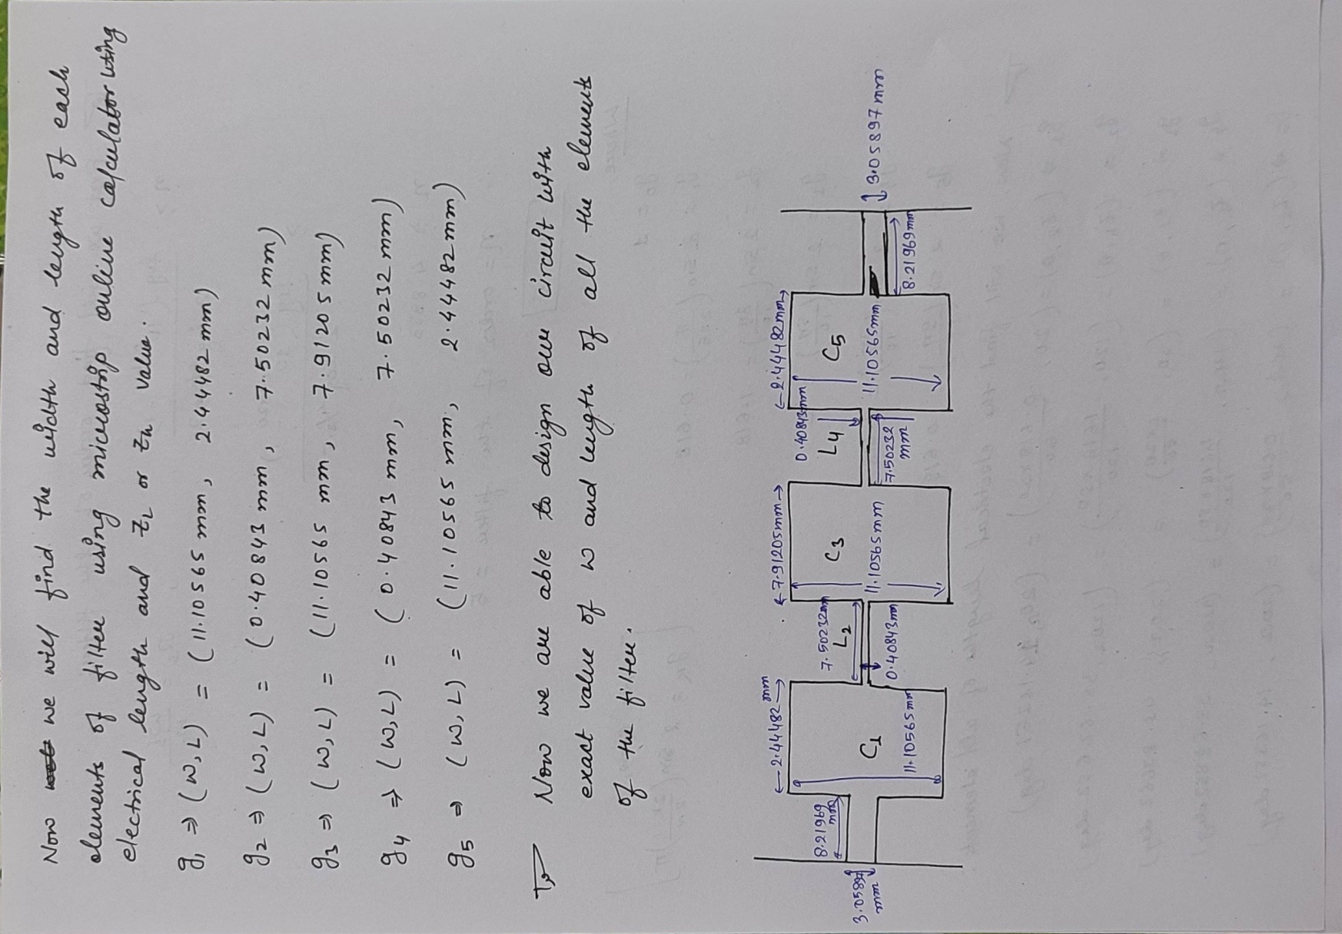

**RESULTS AND PLOTS OBTAINED:**

**1. Plot for S21**

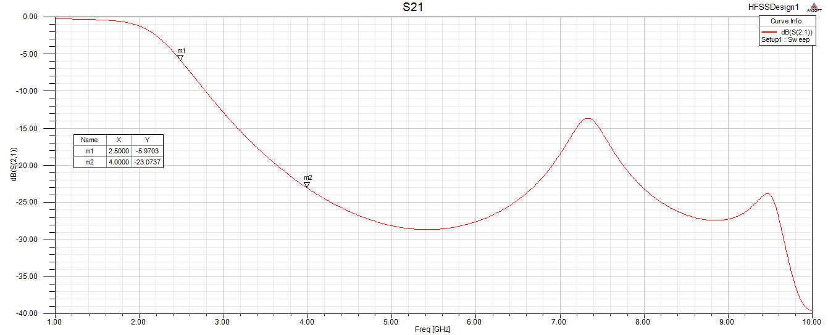

At point m1, we are getting the value of S21 is -5.9703dB at cutoff frequency of 2.5GHz and at point m2 the value of S(2,1) is -23.0737 at frequency of 4GHz.

**2. Plot for S**11

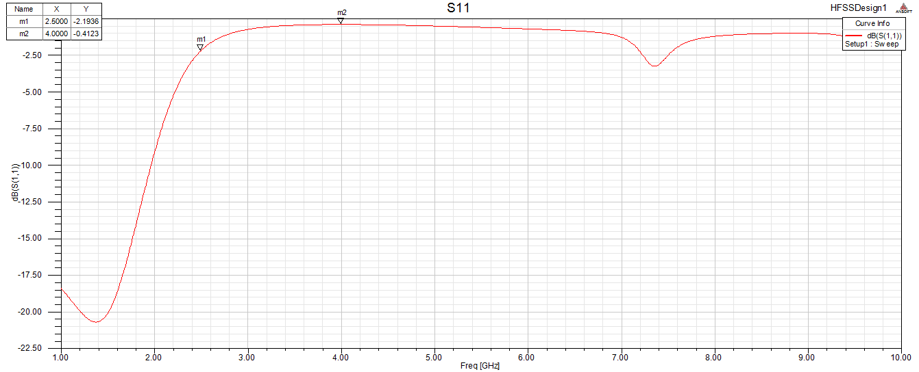

At point m1, we are getting the value of S11 is -2.1936dB at cutoff frequency of 2.5GHz and at point m2 the value of S(2,1) is -0.4123 at frequency of 4GHz.

**CONCLUSIONS:**

The simulated low pass filter structure and its response is shown above. Here due to minimum stop-band attenuation LAS of 20dB at 4GHz, we get number of elements is 5. Here we are taking minimum attenuation value, it can be more than 20dB. In that case where attenuation is very much greater than 20dB, our number of reactive elements will increase, circuit will become complex, area of the circuit will increase, due to these reasons there may create problems in fabrication. Cost will also increase. This product will no longer compact and our daily life we want a very small compact devices which will not possible in such condition. So we should keep the reactive elements as low as possible.